Space Ripoff Visual Studio Setup

1. Create new project in your happy place of choice
2. Install git
3. Do git "setup" instructions from http://github.com
4. run git
5. Clone repo from github.com into your project directory
   1. launch git bash
   2. cd mysolutionfolder
   3. git clone https://github.com/lansdon/SpaceRipoff.git temp
   4. In windows explorer, copy all contents from temp into your project folder (not solution folder) ie: MySolution/MyProject/
6. Load your project in MSVS
7. Right click project in solution explorer → properties
8. 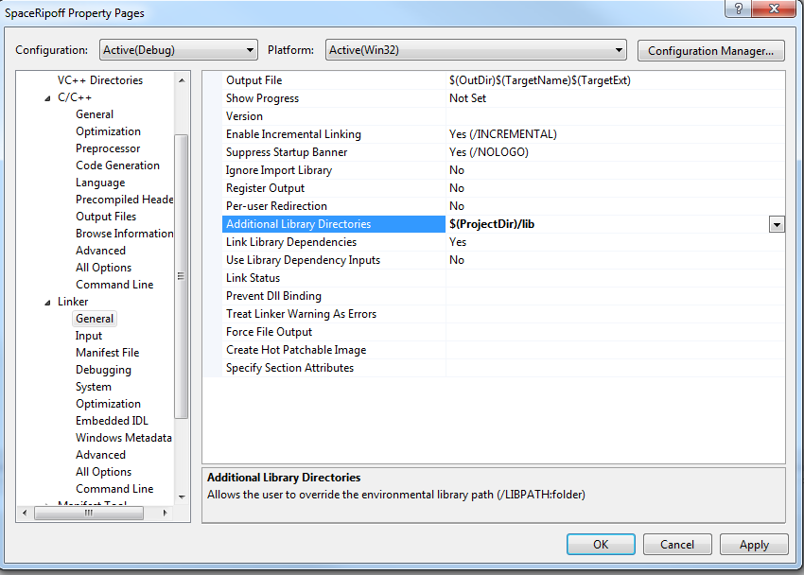
9. 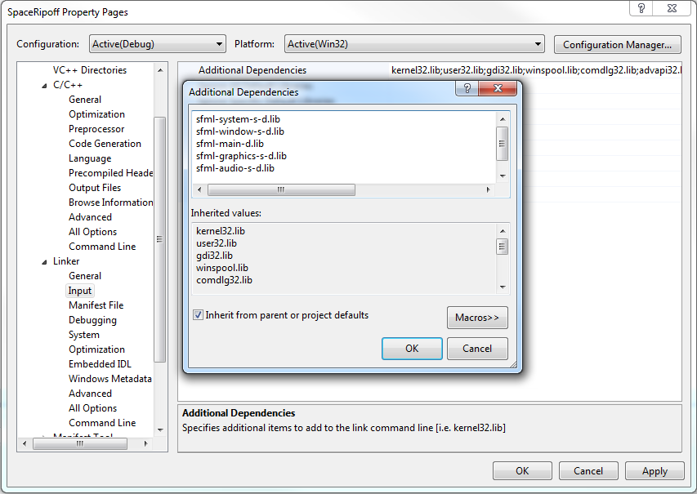
10. 